Row and Column Reduction:

# Question:

Find out the minimum cost of Fig 2 using Row and column reduction method.

|  |  |  |  |  |
| --- | --- | --- | --- | --- |
| - | 10 | 20 | 11 | 15 |
| 14 | - | 2 | 4 | 16 |
| 6 | 5 | - | 15 | 2 |
| 10 | 1 | 4 | - | 3 |
| 11 | 16 | 14 | 18 | - |

Fig 2.

# Python Code:

import numpy as np

A=np.array([[np.inf,10,20,11,15],[14,np.inf,2,4,16],[6,5,np.inf,15,2],[10,1,4,np.inf,3],[11,16,14,18,np.inf]])

A

MinR= np.amin(A, axis=1)

MinR

r=np.zeros([5,5])

for i in range (len(A)):

r[i]=A[i,:]

r[i]=r[i]-MinR[i]

A[i,:]=r[i]

A

MinC= np.amin(A, axis=0)

MinC

c=np.zeros([5,5])

for i in range (len(A)):

c[i]=A[i,:]

c[i]=r[i]-MinC[i]

A[i,:]=c[i]

print(A)

print("Minimum Cost")

costA=MinC+MinR

cost=np.sum(costA[:])

cost

print(cost)

# Output:

[[inf 0. 10. 1. 5.]

[12. inf 0. 2. 14.]

[ 4. 3. inf 13. 0.]

[ 8. -1. 2. inf 1.]

[ 0. 5. 3. 7. inf]]

Minimum Cost

27.0

## Screen Shot:

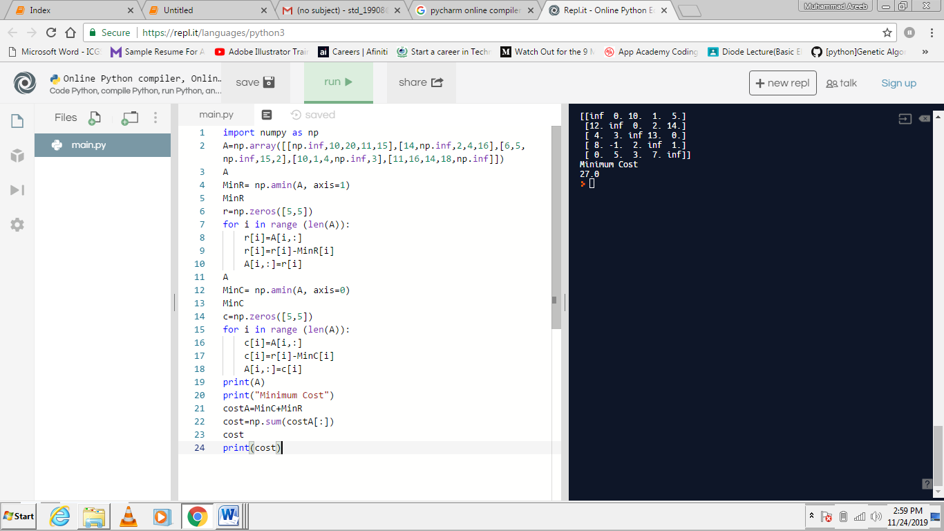c